

INSTRUCTION MANUAL

SCF1000HGa



[**WWW.DAISHIN-JAPAN.CO.JP**](http://WWW.DAISHIN-JAPAN.CO.JP)P･No.15750269002

**Dear Customer:**

We carefully manufactured to give you a dependable operation.

However, similar to all mechanical products, your machine will occasionally require adjustments and maintenance. This manual should be read carefully before operating or performing any adjustments on your machine. Please contact **DAISHIN**　dealer if technical assistance is required.

Please be advised that unit was designed / manufactured for specific applications. So please do not modify and use the unit for any application other than which it was designed for. If you have any questions regarding any applications, please ask **DAISHIN** dealer before using.

**Please read an instruction manual before use.**

**Safety Messages**

Your safety and the safety of others are very important. We have provided important safety messages in this manual and on the generator. Please read these messages carefully.

Safety message alerts you to potential hazards that could hurt you or others. Each safety message is preceded by a safety alert symbol and one of three words; **DANGER**, **WARNING**, or **CAUTION**.

These words mean:

　You will be killed or seriously hurt if you don't follow instructions.

　You can be killed or seriously hurt if you don't follow instructions.

　You can be hurt if you don't follow instructions.

Each message tells you what the hazard is, what can happen, and what you can do to avoid or reduce injury.

Damage Prevention Messages

You will also see other important messages that are preceded by the word.

**NOTICE**

This word means:

 Your generator or other property could be damaged if you don't follow instructions.

The purpose of these messages is to help prevent damage to your generator, other property, or the environment.

**Table of Contents**

1.　SAFETY LABEL LOCATION 3

2.　SAFETY MESSAGES 5

3.　COMPONENTS 7

4.　CONTROLS 9

5.　BEFORE STARTING ENGINE 12

6.　OPERATION 12

7.　STOPPING ENGINE 15

8.　MAINTENANCE 16

9.　TRANSPORTING AND STORAGE 22

10.　WATTAGE INFORMATION 24

11.　TROUBLE SHOOTING 25

12.　SPECIFICATION 27

13.　WIRING DIAGRAM 28

**1.　SAFETY LABEL LOCATION**

These labels warn you of potential hazards that can cause serious injury.

Read them carefully.

If a label comes off or becomes hard to read, contact your DAISHIN dealer for a replacement.











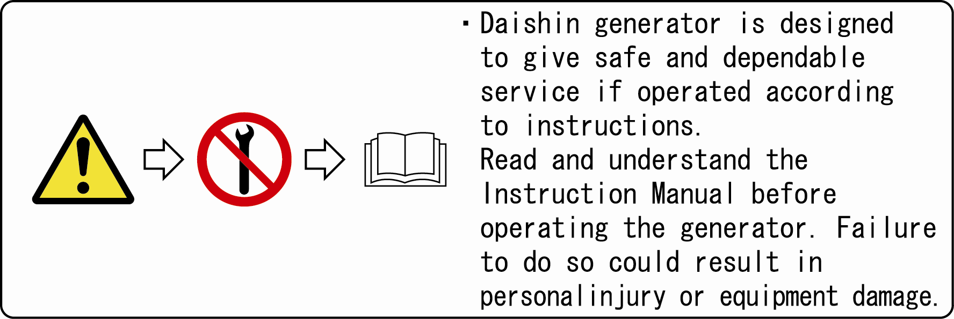

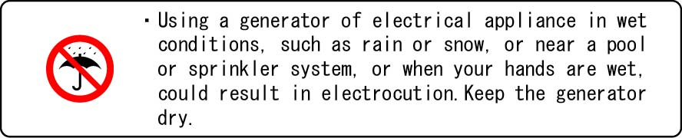

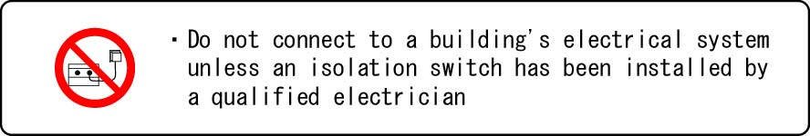

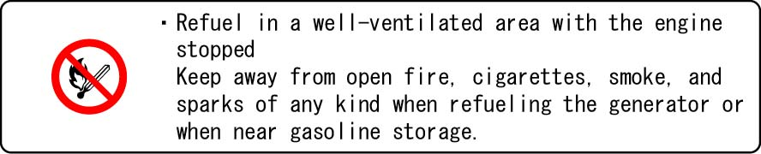

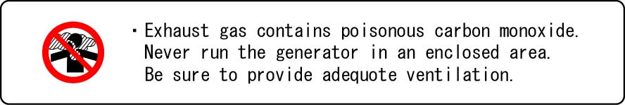



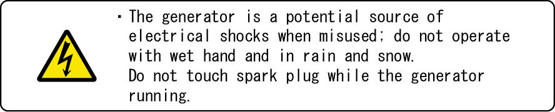

**2.　SAFETY MESSAGES**

Your safety and the safety of others are very important. We have provided important safety messages in this manual and on the generator. Please read these messages carefully.

**Operator responsibility**

・**Know how to stop the generator quickly in case of emergency.**

**・Understand the use of all generator controls, output receptacles, and connections.**

**・Be sure that anyone who operates the generator receives proper instruction. Do not let children operate the generator without parental supervision.**

**Carbon monoxide hazards**

・Exhaust contains poisonous carbon monoxide, a colorless and odorless gas. Breathing exhaust can cause loss of consciousness and may lead to death.

・If you the generator in an area that is confined, or even partially enclosed, the air you breathe could contain a dangerous amount of exhaust gas. To keep exhaust gas from building up, provide adequate ventilation.

**Electric shock hazards**

・The generator produces enough electric power to cause a serious shock or electrocution if misused.

・Using a generator or electrical appliance in wet conditions, such as rain or snow, or near a pool or sprinkler system, or when your hands are wet, could result in electrocution. Keep the generator dry.

・If the generator is stored outdoors, unprotected from the weather, check all electrical components on the control panel, before each use. Moisture or ice can cause a malfunction or short circuit in electrical components, which could result in electrocution.

・Do not connect to a building’s electrical system unless an isolation switch has been installed by a qualified electrician.

**Fire and burn hazards**

・The exhaust system gets hot enough to ignite some materials.

Keep the generator at least 1 meter (3 feet) away from buildings and other equipment during operation.

Do not enclose the generator in any structure.

Keep flammable materials away from the generator.

・The muffler becomes very hot during operation and remains hot for a while after stopping the engine. Be careful not to touch the muffler while is in hot. Let the engine cool before storing the generator indoors.

・Gasoline is extremely flammable and is explosive under certain conditions. Do not smoke or allow flames or sparks where the generator is refueled or where gasoline is stored. Refuel in a well ventilated area with the engine stopped.

・Fuel vapors are extremely flammable and may ignite after the engine has started. Make sure that any spilled fuel has been wiped up before starting, the generator.

**3.　COMPONENTS**

FUEL TANK



CHOKE

OIL FILTER CAP

/DIP STICK

FUEL VALVE

AIR CLEANER

OIL DRAIN BOLT

RICOIL STARTER

GRIP

FUEL TANK CAP

MUFFLER PROTECTOR

SPARK PLUG CAP

CIRCUIT

BREAKER

VOLT METER



GROUND

TERMINAL

ENGINE

SWITCH

**4. CONTROLS**

**Engine switch**

To start and stop the engine.

Switch position:

**Off**: To stop the engine. Key can be removed/ inserted.

**On**: To run the engine after starting.



**Recoil starter**

To start the engine, pull the starter grip lightly until resistance is felt, then

pull briskly.



STATER

GRIP



Do not allow the starter to snap back against the engine.

Return it gently to prevent damage to the starter.

**Fuel valve**

The fuel valve is located between the fuel tank and carburetor.

When the valve lever is in the “ON” position, fuel is allowed to flow from the fuel tank to the carburetor. Be sure to return the lever to “OFF” after stopping the engine.

**OFF**

**ON**

**Choke rod**

The choke is used to provide proper starting mixture when the engine is cold.

It can be opened and closed by operating the choke rod manually.

Pull the rod out toward “CLOSED” to enrich the mixture.



**CLOSED**

**OPEN**

**Ground terminal**

The generator ground terminal is connected to the frame of the generator, the metal non-current carrying parts of the generator, and the ground terminals of each receptacle.

**Oil Alert System**

The oil alert system is designed to prevent engine damage caused by an insufficient amount of oil in the crankcase.

Before the oil level in the crankcase can fall below a safe limit, the oil alert system will automatically to stop the engine (the engines switch will remain in the ON position).

The oil alert system should not take the place of checking the oil level before each use.

If the engine stops and will not restart, check the engine oil level before troubleshooting in order areas.

**Circuit Breaker**

The circuit breaker will automatically switch OFF if there is a short circuit or a significant overload of the generator at the receptacle.

If the circuit breaker is switch OFF automatically, check that the appliance is working properly and does not exceed the rated load capacity of the circuit before switching the circuit breaker ON again.

**5. BEFORE STARTING ENGINE**

1. Fill recommended engine oil to the upper

level if the oil

is short.

1. Change oil if it becomes dirty or discolored.

Oil capacity at upper level mark:

(Oil Capacity 0.4Liter )



UPPER LEVEL



OIL FILLER HOLE

OIL FILLER CAP

**6. OPERATION**

**1. STARTING THE ENGINE**

1. Make sure that disconnect all electrical loads from panel receptacles.

The generator may be hard to start if a load is connected.

2. Turn the fuel valve to the “ON” position.



**OFF**

**ON**

3. If you want to start operate the choke manually, move the choke rod out to the “CLOSED” position.



**CLOSED**

**OPEN**

Start the engine: Pull the starter grip lightly until resistance is felt,

then pull briskly.

 **Do not allow the starter grip to snap back against the engine. Return it gently to prevent damage to the starter or housing.**

4. Do not allow the starter grip to snap back against the engine. Return it gently to prevent damage to the starter or housing.



5. If you have manually closed the choke, move it to the “OPEN” position as the engine warms up.



**OPEN**

**CLOSED**

**2. APPLYING AC LOAD**

1. Start engine (see STARTING THE ENGINE).

2. Allow the engine to warm up for 2-3 minutes before connecting tools or appliances.

3. Insert the plug of the electrical appliance into “AC RECEPTACLE”.



** Do not take a current exceeding the specified amperage.

** Be sure that total wattage of all appliances does not exceed the rated output of the generator.

** Limit length of extension cables: 60m for cables of 1.5mm2 and 100m for cables of 2.5mm2.



When the generator is overloaded or a short circuit is made, the CIRCUIT BREAKER will trip to protect the circuit automatically.

If CIRCUIT BREAKER trips during operation, the generator is either over loaded or the appliance is defective.

Check the appliance and / or generator for overloading or defect make necessary corrections or repairs before use.

**BE SURE THAT THE TOTAL WATTAGE OF ALL APPLIANCES DOES NOT EXCEED THE RATED OUTPUT OF THE GENERATOR.**

**7. STOPPING ENGINE**

1. To stop the engine in an emergency, turn the engine switch to the “OFF” position.

2. Disconnect all electrical loads from panel receptacles.

3. Turn the fuel valve to the “OFF” position.

**ENGINE SWITCH**





**OFF**

**ON**



Never leave an appliance plugged into the generator when you stop the generator as damage could result to the generator and / or appliance.

**8. MAINTENANCE**

Periodic inspection and adjustment of ENGINE & Generator is essential if high-level performance is to be maintained. Regular maintenance will also ensure a long service life.



Exhaust gas contains poisonous carbon monoxide.

Shut off the engine before performing any maintenance, if the engine must be run, make sure the areas is well ventilated.



Use only genuine parts or their equivalent for maintenance or repair.

Replacement parts, which are not of equivalent quality, may damage the generator.

MAINTENANCE SCHEDULE

|  |  |  |  |  |  |
| --- | --- | --- | --- | --- | --- |
| REGULAR SERVISE PERIOD  Performed at every indicated month or operating hour interval, whichever comes first. | | Each use | First month or 25Hrs. (3) | Every 3month or 50Hrs. (3) | Every 6month or 100Hrs. (3) |
| ITEM |  |
| Engine oil | Check level | O |  |  |  |
|  | Change |  | O | O |  |
| Air cleaner | Check | O |  |  |  |
|  | Clean |  |  | O (1) |  |
| Spark plug | Check-Clean |  |  | O |  |
| Valve clearance | Check-Adjust |  |  |  | O (2) |
| Fuel tank and strainer | Clean |  |  |  | O (2) |
| Fuel line | Check  (Replace if necessary) | Every 2 years (2) | | | |

* + 1. Service more frequently when used in dusty areas.
    2. These items should be service by your dealer, unless the owner has the proper tools and is mechanically proficient. See the service manual.
    3. For professional commercial use, log has of operation to determine proper maintenance intervals.

**Engine oil**

**Engine oil is a major factor affecting engine performance and service life.**

**No detergent and 2­stroke engine oils will damage the engine and are not recommended.**

Check the oil level BEFORE EACH USE with the generator on a level surface with the engine stopped.

Use　a high quality detergent oil classified “For Service SF,SG,SH,SJ” .

Use no special additives with recommended oils. Do not mix oil with gasoline.

**Air-cooled engines run hotter than automotive engines. The use of no-synthetic multi-viscosity oils (5W-30,10W-30,etc.)in temperatures above 40°F(4℃), will result in higher than normal oil consumption. When using multi-viscosity oil, check oil level more frequently

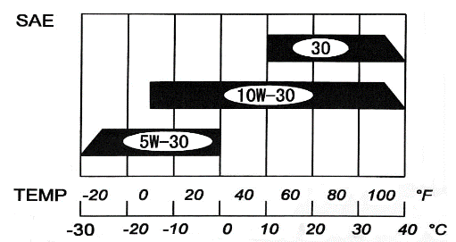

Ambient temperature

** SAE30 oil, if used below 40°F (4℃), will result in hard starting and possible engine bore damage due to inadequate lubrication.

**Engine oil change**

1. Drain the oil while the engine is warm to assure rapid and complete draining.

2. Remove the drain plug and sealing washer, oil filler cap, and drain the oil.

3. Reinstall the drain plug and sealing washer.

Tighten the plug securely.

4. Refill with the recommended oil and check the level.



UPPER LEVEL



OIL FILLER HOLE

OIL FILLER CAP

**Oil capacity: 0.4 Liter**



Used motor oil may cause skin cancer if repeatedly left in contact with the skin for prolonged periods. Although this is unlikely unless you handle used oil on a daily basis, it is still advisable to thoroughly wash your hands with soap and water as soon as possible after handling used oil.

Please dispose of used motor oil in a manner that is compatible with the environment.

We suggest you take it in a sealed container to your local service station or recycling center for reclamation. Do not throw it in the trash or pour it on the ground.

**Refueling**

**Fuel tank capacity: 8.5 Liter**

Check the fuel level gauge, and refill the tank if the fuel level is low.



Gasoline is highly flammable and explosive, and you can be burned or seriously injured when handling fuel.

**・Stop engine and keep heat, sparks, and flame away.**

**・Handle fuel only outdoors.**

**・Wipe up spills immediately.**

Refuel in a well-ventilated area before starting the engine. If the engine has been running, allow it to cool. Refuel carefully to avoid spilling. Do not fill above the shoulder of the fuel strainer. After refueling, tighten the fuel tank cap securely.

Never refuel the generator inside a building where gasoline fumes may reach flames or sparks. Keep gasoline away from appliance pilot lights, barbecues, electric appliances, power tools, etc.

Spilled fuel is not only a fire hazard, it causes environmental damage. Wipe up spills immediately.

FUEL STRAINER

SHOULDER

FUEL FILTER CAP



**Speak plug service**

**Recommended spark plugs:**  **E5T**

To ensure proper engine operation, the spark plug must be properly gapped and free of deposits.

If the engine has been running, the muffler will by very hot.

Be careful not to touch the muffler.

1. Remove the spark plug cap.

2. Clean any dirt from around the spark plug base.

3. Use the wrench supplied in the tool kit to remove the spark plug.



PLUG CAP

4. Visually inspect the spark plug. Discard it if the insulator is cracked or chipped. Clean the spark plug with a wire brush if it is to be reused.

5. Measure the plug gap with a feeler gauge.

Correct as necessary by carefully bending the side electrode.

0.70～0.80mm

(0.028～0.031in)

The gap should be: 0.7mm－0.8mm

（0.028 ～0.031 in）

6. Check that the spark plug washer is in good condition, and thread the spark plug in by hand to prevent cross-threading.

7. After the spark plug is seated, tighten with a spark plug wrench to compress the washer.

-If installing a new spark plug, tighten 1/2 turn after the spark plug seats to compress the washer. If reinstalling a used spark plug, tighten 1/8-1/4 turn after the spark plug seats to compress the washer.



**The spark plug must be securely tightened.**

**An improperly tightened spark plug can become very hot and could damage the engine.**

**Never use spark plugs which have an improper heat range.**

**Use only the recommended spark plugs or equivalent.**

**Air cleaner service**

A dirty air cleaner will restrict air flow to the carburetor.

To prevent carburetor malfunction, service the air cleaner regularly.

Service more frequently when operating the generator in extremely dusty areas.



**Using gasoline or flammable solvent to clean the filter element can cause a fire or explosion. Use only soapy water or nonflammable solvent.**



**Never run the generator without the air cleaner. Rapid engine wear will result.**

1. Unsnap the air cleaner cover clips, remove the air cleaner cover, and remove the element.

2. Wash the element in a solution of household detergent and warm water, then rinse thoroughly; or wash in nonflammable or high flash point solvent. Allow the element to dry thoroughly.

3. Soak the element in clean engine oil and squeeze out the excess oil.

The engine will smoke during initial start-up it too much oil is left in the element.

4. Reinstall the air cleaner element and the cover.



ELEMENT

ELEMENT

AIR CLEANER COVER

**9. TRANSPORTING AND STORAGE**

When transporting the generator, turn the engine switch and the fuel valve “OFF”. Keep the generator level to prevent fuel spillage.

Fuel vapor or spilled fuel may ignite.



Contact with a hot engine or exhaust system can cause serious burns or fires.

Let the engine cool before transporting or storing the generator.

Take care not to drop or strike the generator when transporting. Do not place heavy objects on the generator.

Before storing the unit for an extended period:

1. Be sure the storage area is free of excessive humidity and dust.

2. Service according to the table below:

|  |  |
| --- | --- |
| STORAGE TIME | RECOMMENDED SERVICE PROCEDURE TO PREVENT HARD STARTING |
| Less than 1 month | No preparation required. |
| 1 to 2 months | Fill with fresh gasoline and add gasoline conditioner*. |
| 2 months to 1 year | Fill with fresh gasoline and add gasoline conditioner*.  Drain the carburetor float bowl.  Drain the fuel sediment cup. |
| More than 1 year | Fill with fresh gasoline and add gasoline conditioner*.  Drain the carburetor float bowl.  Drain the fuel sediment cup.  Remove the spark plug. Put a tablespoon of engine oil into the cylinder. Turn the engine slowly with the pull rope to distribute the oil. Reinstall the spark plug. Change the engine oil.  After removal from storage, drain the stored gasoline into a suitable container, and fill with fresh gasoline before starting. |
| * Use gasoline conditioners that are formulated to extend storage life.  Contact your authorized DAISHIN dealer for conditioner recommendations. | |

1. Drain the carburetor by loosening the drain screw. Drain the gasoline into a suitable container.



Gasoline is extremely flammable and is explosive under certain conditions.

Perform this task in a well ventilated area with the engine stopped. Do not smoke or allow flames or sparks in the area during this procedure.



DRAIN SCREW

2. Change the engine oil.

3. Remove the spark plug, and pour about a tablespoon of clean engine oil into the cylinder.

Crank the engine several revolutions distribute the oil, then reinstall the spark plug.

4. Slowly pull the starter grip until resistance is felt.

At this point, the piston is coming up on its compression stroke and both the intake and exhaust valves are closed.

Storing the engine in this position will help to protect it from internal corrosion.



**10. WATTAGE INFORMATION**

Some appliance needs a “surge” of energy at starting.

This means that the amount of electrical power needed to start the appliance may exceed the amount needed to maintain its use. See the chart below for appliances you may use with this generator.

Electrical appliance and tools normally come with a label indicating voltage, cycles/ HZ, amperage and electrical power needed to run the appliance or tool. If no specification label is found, check with your nearest dealer for the power surge of your appliances or power tools.



The following wattage chart is guidance only.

Refer to your specific appliance for correct wattage.

**APPLICABLE WATTAGE (W)**

|  |  |
| --- | --- |
| SCF1000HGa | WATTAGE (W) |
| INCANDESCENT LAMP,  HEATER | 850 |
| FLUORESCENT LAMP,  MARCURY LAMP | 400 |
| ELECTRIC TOOLS | 400 |

**11. TROUBLE SHOOTING**





**12. SPECIFICATION**



**13. WIRING DIAGRAM**



MEMO

MEMO

**DAISHIN　INDUSTRIES　LTD.**

1520-1,FUNATSUKE,YORO－CHO,

YORO－GUN,GIFU 503-1382 JAPAN

PHONE : 81-(0)584-36-0501

FAX : 81-(0)584-36-0504

URL : http://www.daishin-japan.co.jp

MAIL : overseas@daishin-japan.co.jp



**DAISHIN　INDUSTRIES　LTD.**

1520-1,FUNATSUKE,YORO－CHO,

YORO－GUN,GIFU 503-1382 JAPAN

PHONE : 81-(0)584-36-0501

FAX : 81-(0)584-36-0504

URL : http://www.daishin-japan.co.jp

MAIL : overseas@daishin-japan.co.jp